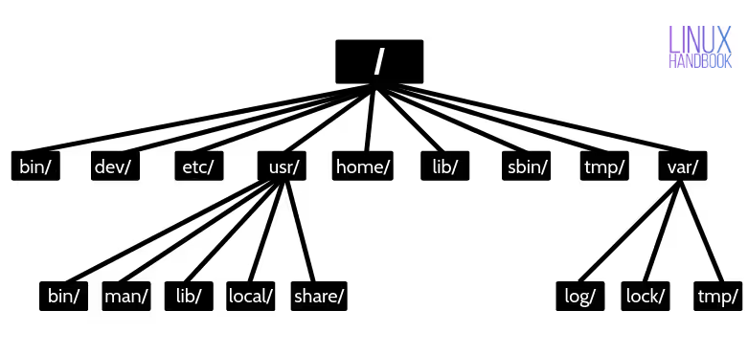

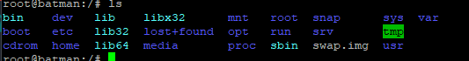

• bin: Contains essential user command binaries that are needed for all users (e.g., basic system commands).
• boot: Holds files necessary for booting the system, such as the Linux kernel and bootloader files.
• dev: Device files that represent hardware devices (disks, terminals, etc.), allowing the system and users to interact with hardware.
• lib / lib32: Libraries needed by the system to run programs, including shared libraries for binaries in /bin and /sbin.
• mnt: A directory traditionally used for mounting temporary filesystems or external devices.
• root: The home directory for the root user.
• snap: Contains snap packages (containerized software applications).
• sys: A virtual filesystem providing information about kernel devices and drivers.
• var: Variable data like logs, spool files, and temporary files that change during system operation.
• tmp: Temporary files created by the system and users, usually cleared on reboot.
• usr: Contains secondary program data, including user applications and libraries.
Certainly! Here's a detailed explanation of each directory with examples to illustrate their use cases:

---

1. bin/
- Description: Contains essential user commands needed for basic operation, available to all users.
- Use case: Basic commands required for system operation or troubleshooting.
Examples:
- `ls` – list directory contents
- `cp` – copy files
- `mv` – move or rename files
- `cat` – display file contents
- `grep` – search text in files

---

2. dev/
- Description: Contains device files representing hardware devices, acting as interfaces to hardware components.
- Use case: Access hardware like disks or peripherals through special files.
Examples:
- `/dev/sda` – first hard disk
- `/dev/tty` – terminal interface
- `/dev/null` – discard output streams

---

3. etc/
- Description: Contains system-wide configuration files and startup scripts.
- Use case: Configure system services, network settings, user info, and environment variables.
Examples:
- `/etc/passwd` – user account information
- `/etc/hosts` – static hostname mappings
- `/etc/network/interfaces` – network configuration
- `/etc/ssh/sshd_config` – SSH server configuration

---

4. usr/
- Description: Contains read-only data for user applications and utilities.
- Use case: Application software, documentation, and libraries used by users.
Examples:
- `/usr/bin/` – additional user commands like `vim`, `gcc`
- `/usr/lib/` – shared libraries for applications
- `/usr/share/` – shared data like icons, documentation

---

5. home/
- Description: Contains individual user directories.
- Use case: Store personal files, documents, and user-specific configurations.
Examples:
- `/home/alice/` – Alice’s personal files and settings
- `/home/bob/` – Bob’s personal files

---

6. lib/
- Description: Contains shared libraries needed to run binaries located in `/bin/` and `/sbin/`.
- Use case: Libraries like `libc.so` used by system programs.
Examples:
- `/lib/libc.so.6` – standard C library
- `/lib/ld-linux.so.2` – dynamic linker

---

7. sbin/
- Description: Contains system administration binaries, mainly used by root.
- Use case: System maintenance and configuration commands.
Examples:
- `/sbin/reboot` – restart system
- `/sbin/fsck` – check and repair filesystems
- `/sbin/ifconfig` – configure network interfaces

---

8. tmp/
- Description: Temporary directory for files created during system or user operations.
- Use case: Store temporary data that doesn't need to persist after reboot.
Examples:
- Temporary files created during software installation
- Session files or cache files

---

9. var/
- Description: Stores variable data like logs, mail, and spool files.
- Use case: Data that changes frequently or needs to be preserved.
Examples:

- /var/log/ – system logs, e.g., `/var/log/syslog` or `/var/log/messages`
- /var/mail/ – user mailboxes
- /var/spool/ – print jobs, mail queues
- /var/www/ – web server files (if hosting websites)

---

Subdirectories inside /usr/

- /usr/bin/
- Additional commands for users, e.g., `gcc`, `python`, `vim`.
- Example: `/usr/bin/vim` (text editor)

- /usr/lib/
- Libraries for applications in `/usr/bin/`.
- Example: `/usr/lib/libpython3.8.so`

- /usr/share/
- Architecture-independent data, like icons, documentation, and default configs.
- Example: `/usr/share/icons/`

- /usr/local/
- Locally installed software or custom-built applications.
- Example: `/usr/local/bin/customscript`

Directory | Use Case | Example Files/Commands
/bin/ | Essential commands for all users | ls, cp, mv
/dev/ | Hardware interfaces | /dev/sda, /dev/tty
/etc/ | System configurations | /etc/passwd, /etc/hosts
/usr/ | User applications and data | /usr/bin/vim, /usr/share/doc/
/home/ | User personal files | /home/alice/Documents
/lib/ | Shared libraries | /lib/libc.so.6
/sbin/ | System admin tools | /sbin/reboot, /sbin/ifconfig
/tmp/ | Temporary data | Session files, cache
/var/ | Variable data | Log files, mail queues

